**CEN103 Coursework Laboratory Experiment Report**

**Contents**

**1. Introduction** **2**

**2. Theory** **2**

**3. Experiments** **3**

3.1 Methods 3

3.2 Results 4

**4. Discussion** **11**

**5. Conclusions** **12**

**1. Introduction**

In order to fulfill the requirements for CEN103 and to better understand truss, shear force and bending moment, we conducted this experiment. In the experiment, three practical and virtual experiments on a roof truss and on beams determining bending moments and shear forces were included. Only the experiment on shear force in a beam will be described in this report according to the arrangement of lecturer. In this report, firstly, some relevant theory will be introduced first to make the reader more clear about the principles of the experiment taken. And then the experiment method and results will be given, which is the most significant part. Discussions about the results and conclusion of the finding will be presented at last.

**2. Theory**

Shear force is a kind of force which acts in a direction parallel to a surface or to a planar cross section of a body. To calculate the shear force in a beam, support reactions should be determined at first. It is a must to recognize the reaction force. And then the free-body diagram is supposed to be drawn before using equations. Last but not least, the equations of equilibrium are indispensable.

During the experiment on the shear force in a beam, the following equations are needed to calculate the shear force in the beam.

1. First, apply the equilibrium in y direction:

Where is the support reaction on the left side, is the support reaction on the right side, F is the whole force on the beam.

2. For one load situation, calculate the moment about that load point:

Where is the length from the left supporting point to the load point, is the length from the right supporting point to the load point.

For two load situation, calculate the moment about one load point:

Where is the length from the left supporting point to the load point, is the length from the right supporting point to the load point, is the length from the one load point to another load point, is the other load force different from the one we calculate the moment about.

3. Finally, apply the equilibrium to the right side of the “cut” position:

Where *V* is the shear force at the “cut” position.

Since there is a different between chooses of the positive direction, we all use the magnitude of the V to discuss and compare.

**3. Experiments**

**3.1 Methods**

In the experiments I and II, two masses, and , were applied to the beam, was applied on the position of x = 400mm, and was applied on the position of x = 260mm which our team chose.

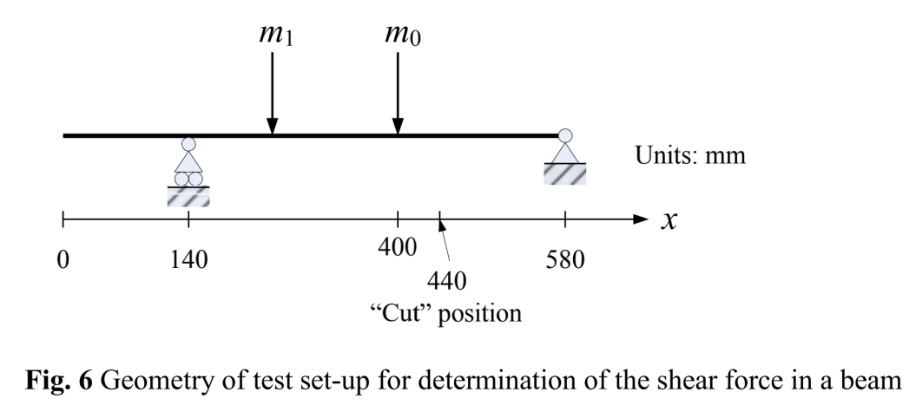

In practical experiment, we first zeroed the equipment, that is, without adding any weight, adjust the number on the shear force display to 0N. After this operation, we started with experiment I.

In the first experiment, equals to 0, which means we only need one weight to apply on the beam. Therefore, we applied on the beam with five different values which are 0, 100g, 200g, 300g, and 400g. The results of these five measurement were recorded. In particular, for = 100g and = 400g, the theoretical shear force diagrams were captured and a graph showing the shear force at the “cut” position (x=440mm) as a function of the applied loads were made.

In the experiment II, 8 combinations of loads and were applied on the beam.

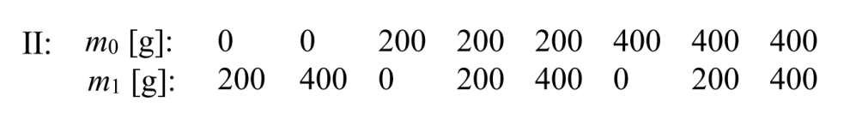

The theoretical shear force diagrams for all combinations were shown in the result and tables showing the measured and theoretical values of shear forces were presented for a further comparison.

In the experiment III, which is a virtual experiment on TecQuipment software, 8 load combinations shown below were applied on the beam, and the shear force diagrams were captured in the software.

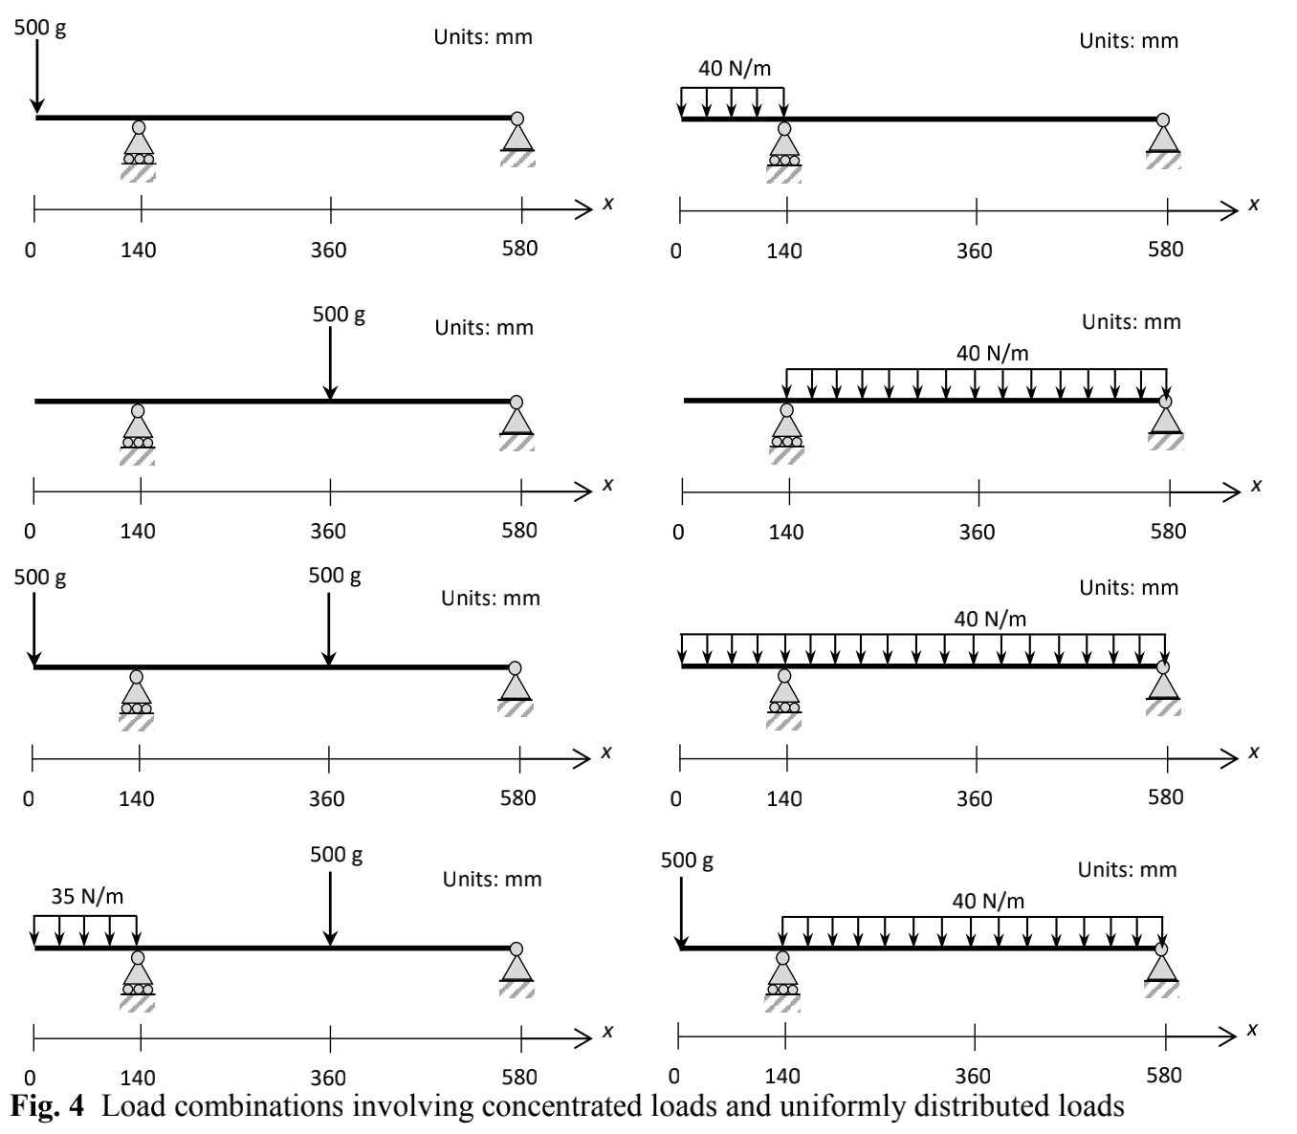

**3.2 Results**

3.2.1 Experiment I

3.2.1.1

For experiment I, two figures showing the theoretical shear force diagrams for the applied masses =100g and are shown in graph 1 and 2.

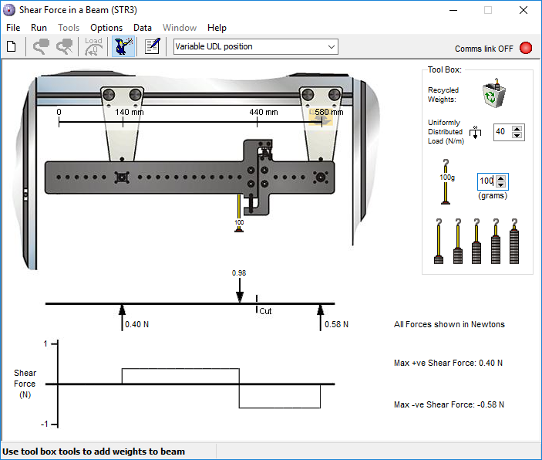

Graph 1: shear force diagram for m0 = 100g

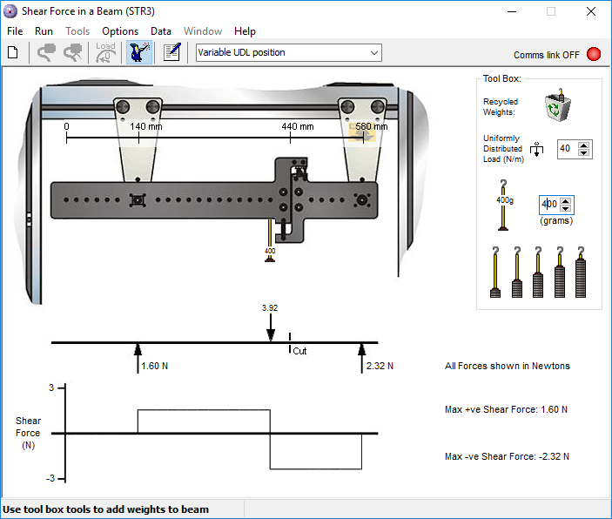

Graph 2: shear force diagram for m0 = 400g

3.2.1.2

A graph showing the shear force at the “cut” position as a function of the applied loads is shown below as graph 3.

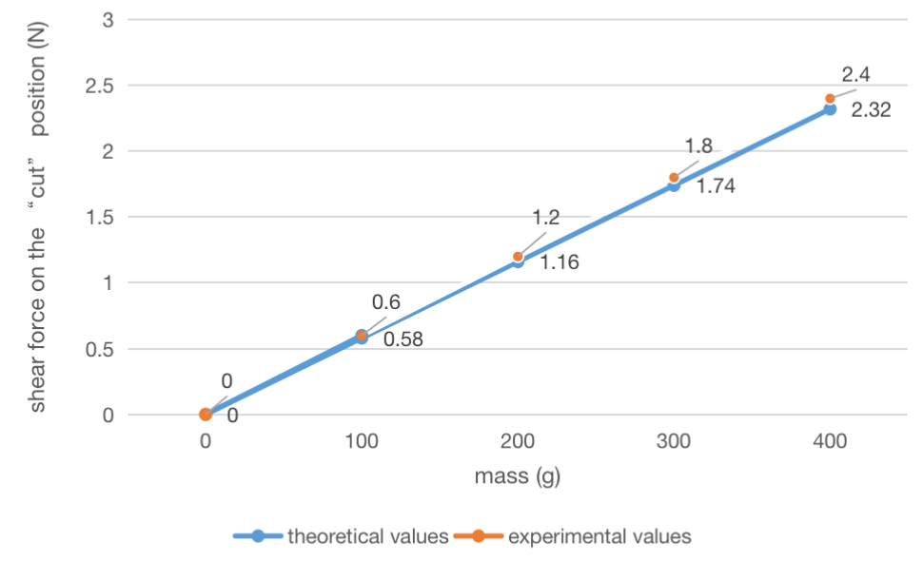

Graph 3: the shear force at the “cut” position as a function of the applied loads

As the graph shows, the shear force at the “cut” position increases linearly with the increase in mass. For experimental values, the numerical accuracy is not as good as ideal data, but it approximately matches the ideal data. Since the particular magnitude of the shear force equals to the right side support reaction, which calculated by the equilibrium of moment, it is liner to the load applied to the beam, therefore, liner to the mass value.

3.2.2 Experiment II

3.2.2.1

For experiment II, figures showing the theoretical shear force diagrams for all the load combinations are as following graph 4-11:

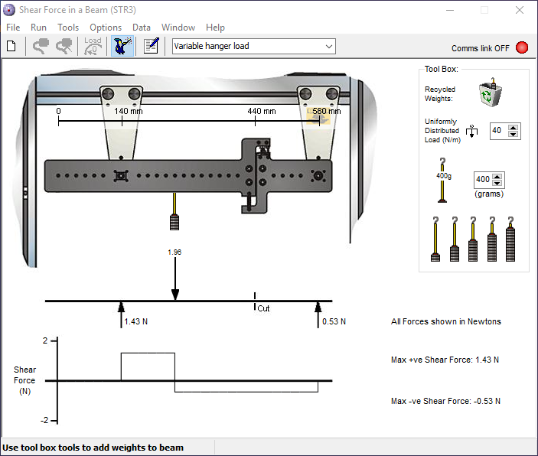

Graph 4: m0 = 0, m1 = 200g

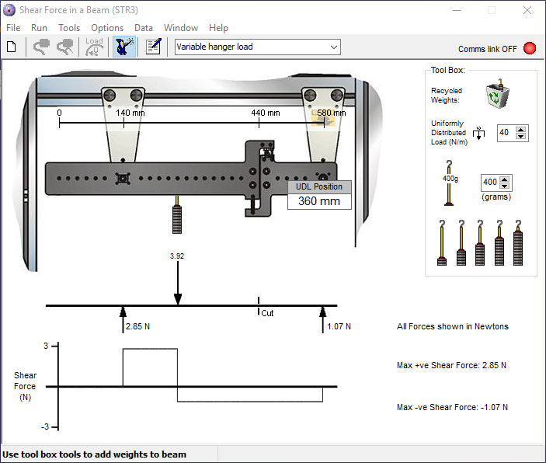

Graph 5: m0 = 0, m1 = 400g

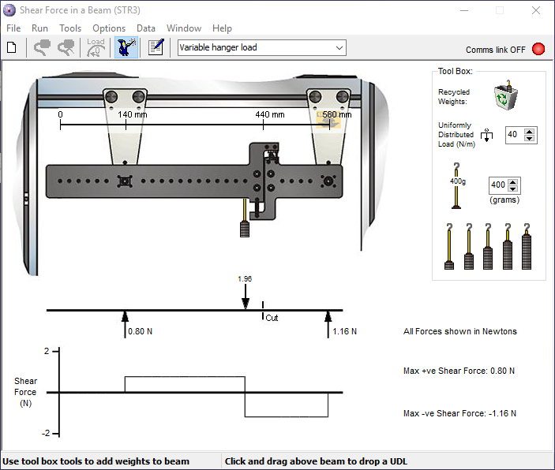

Graph 6: m0 = 200g, m1 = 0

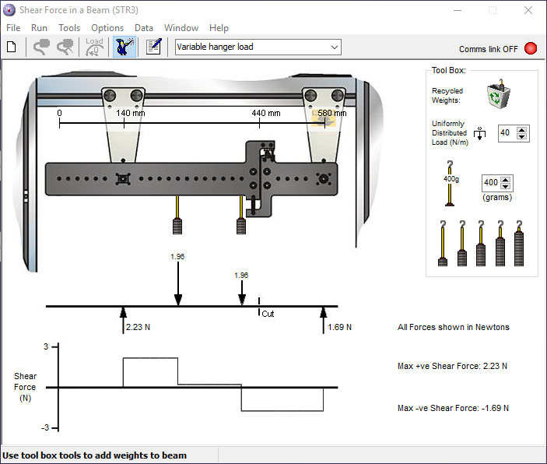

Graph 7: m0 = 200g, m1 = 200g

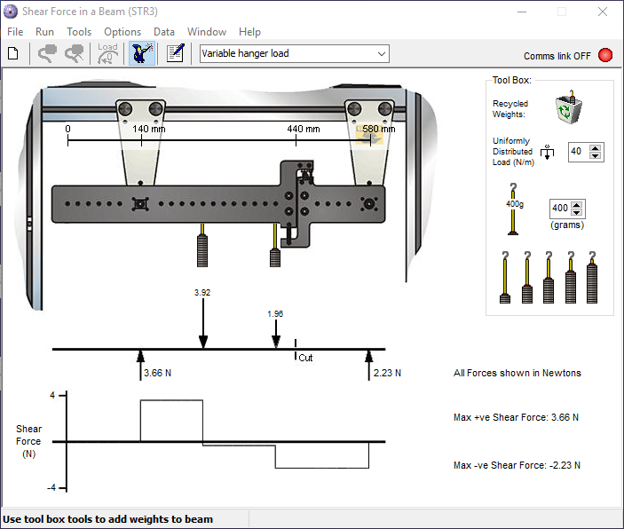

Graph 8: m0 = 200g, m1 = 400g

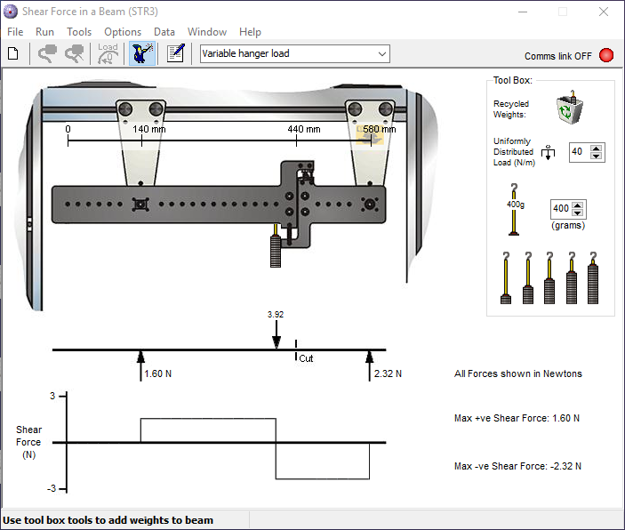

Graph 9: m0 = 400g, m1 = 0

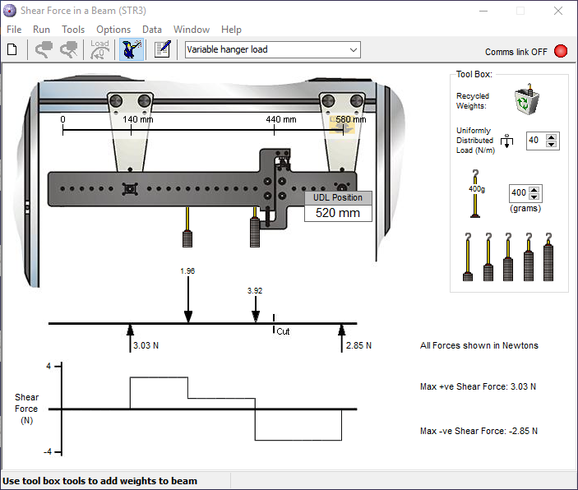

Graph 10: m0 = 400g, m1 = 200g

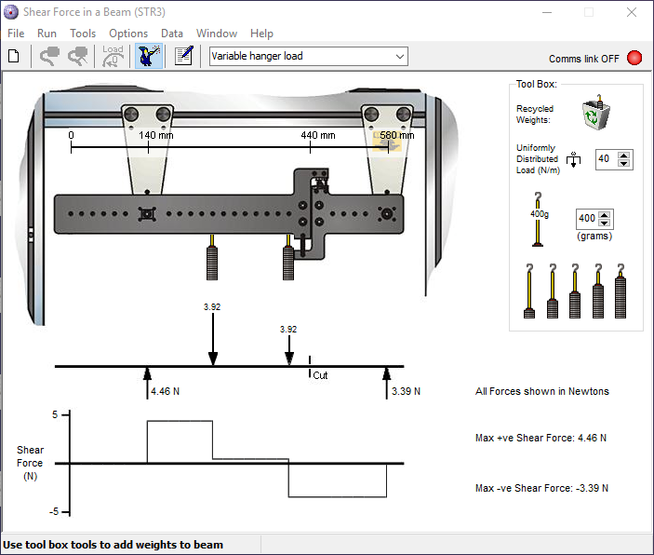

Graph 11: m0 = 400g, m1 = 400g

As these 8 figures shows, the shear force on the “cut” position is related to the loads applied on the beam. There are two findings related to the loads value and the shear force. First, in the case of a certain load quantity, the greater the Loads value, the greater the shear force. Second, for the same loads value, the closer to the cut position, the greater the shear force.

3.2.2.2

A table showing the theoretical and measured values of the shear force at the “cut” position for all the load combinations are as following.

|  |  |  |  |  |  |  |  |  |
| --- | --- | --- | --- | --- | --- | --- | --- | --- |
| m0 (g) | 0 | 0 | 200 | 200 | 200 | 400 | 400 | 400 |
| m1 (g) | 200 | 400 | 0 | 200 | 400 | 0 | 200 | 400 |
| theoretical shear force (N) | 0.53 | 1.07 | 1.16 | 1.69 | 2.23 | 2.32 | 2.85 | 3.39 |
| experimental shear force (N) | 0.5 | 1.1 | 1.2 | 1.7 | 2.3 | 2.4 | 3 | 3.5 |

Table 1: theoretical and measured values of the shear force at the “cut” position

From the table above, it is easy to find that there are little difference between the theoretical an measured values of the shear force at the “cut” position. However, the measured values are usually bigger than theoretical ones, which will be discussed at the discussion part.

3.2.3 Experiment III

In experiment III, 8 graphs of shear force diagrams for the given loads were shown as graph 12-19:

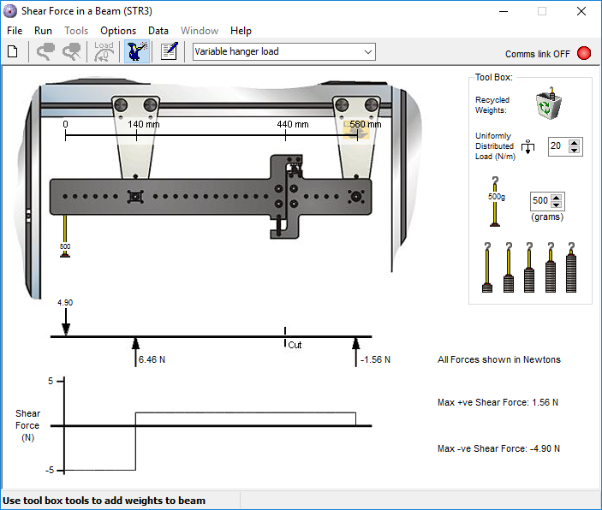

Graph 12

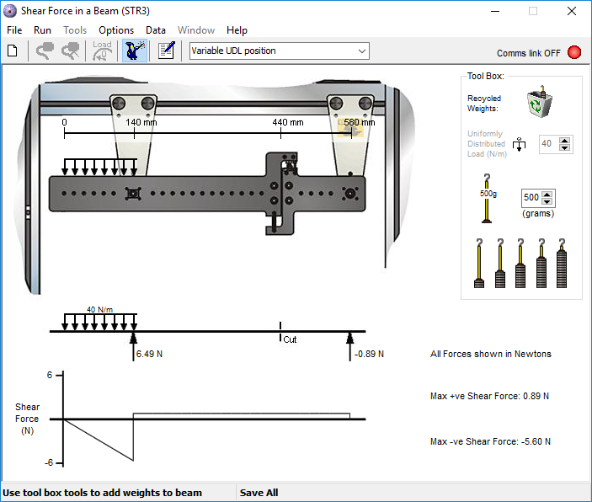

Graph 13

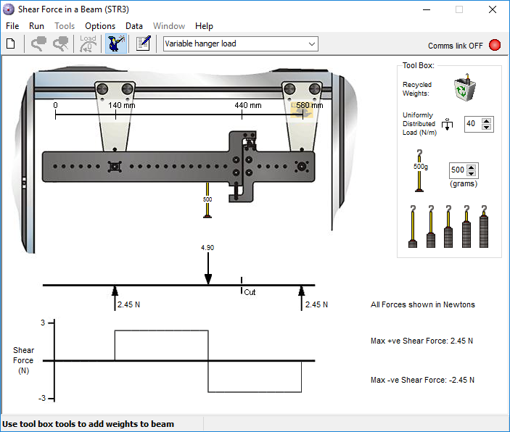

Graph 14

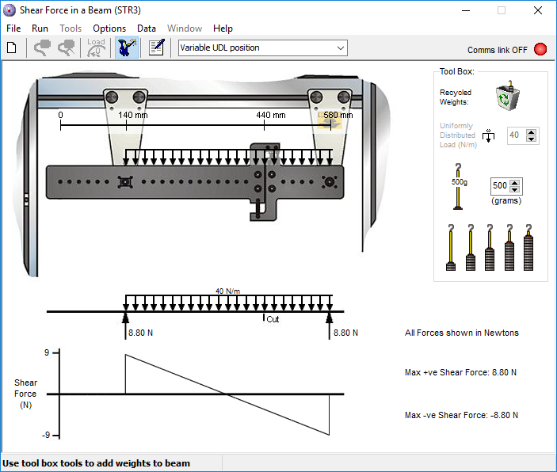

Graph 15

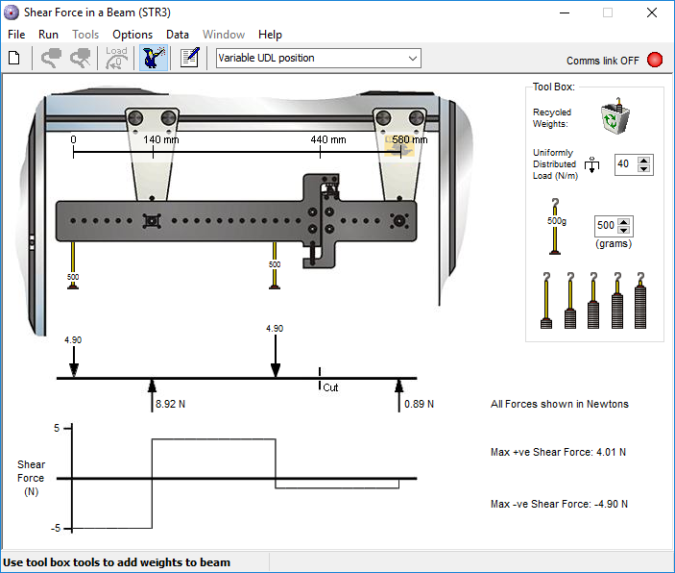

Graph 16

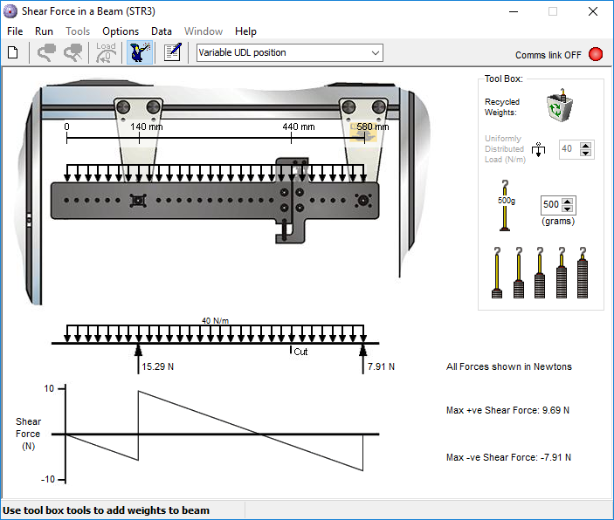

Graph 17

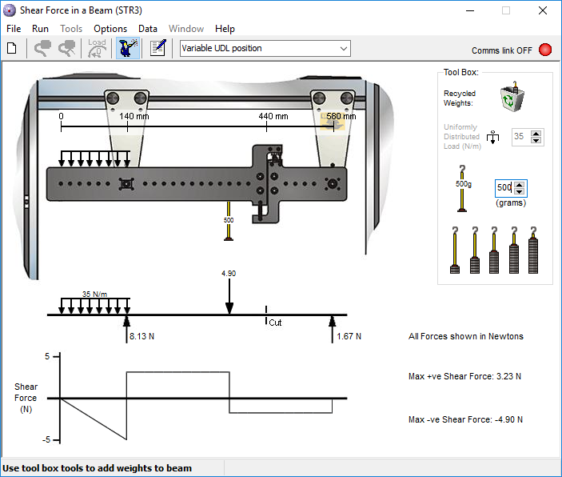

Graph 18

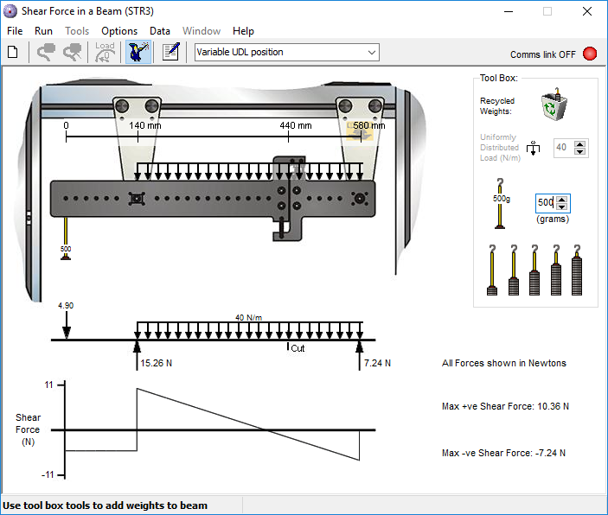

Graph 19

From these eight graphs, we can find that when the force on the beam is concentrated loads, the shear force diagram presents a fixed constant value in each section. When the force on the beam is uniformly distributed loads, the shear force diagram shows a linear function value that varies according to the distance in the corresponding segment.

**4. Discussion**

As the results shows, there are some findings we discovered in the experiment.

First, when only one force is applied to the beam, that is, there is only one load, the shear force at “cut” position has a linear relationship with the weight of the weight placed. Second, when there are two forces acting on the beam, the closer the force is to the "cut" position, the greater the shear force. Third, when two different forces act on the beam, the shear force diagram will be different, and the specific changes will be the same as written in 3.2.3: when the force on the beam is concentrated loads, the shear force diagram presents a fixed constant value in each section; when the force on the beam is uniformly distributed loads, the shear force diagram shows a linear function value that varies according to the distance in the corresponding segment.

**5. Conclusions**

In conclusion, there are some differences between the simulated experiment and the actual experiment. In actual experiments, the mass of the weight is not necessarily accurate, which leads to inaccurate force on the beam. At the same time, the accuracy of the numbers on the shear force display is not accurate enough, only one digit after the decimal point, while the numbers in the virtual experiment are more accurate, reaching the accuracy of two digits after the decimal point.

In this experiment, we have a better understanding of the calculation process of the shear force, the factors that affect the magnitude of the shear force, and the factors that affect the shear force diagram. This will be of great help to our future studies.